VM Ware Session

1. Advantages and Disadvantages of On-Premise and Cloud Infrastructure are mentioned below:
   1. Advantages of On Premise Infrastructure
      1. **Internet**: In this case internet is not required as everything is available on premise.
      2. **Security**: In this case since everything is stored on premises and not on cloud, there are negligible chances of the data being spied on or data being shared to any third party outside the premises.
      3. **Control**: Since the server is present on premises you can upgrade, make changes etc without the need to contact any third party to fulfill your needs.
   2. Disadvantages of On Premise Infrastructure
      1. **Support**: Since you are managing everything on premises you need to have IT engineers to handle the infrastructure which will increase the cost as you are hiring employees or your current staff would devote their time to manage these servers.
      2. **Maintenance**: Excluding the initial investment to install infrastructure, you will be forced to pay high maintenance cost to keep using this services.
      3. **Upgrading**: In future when you feel to upgrade your servers on premise since you will be required to install hardware and more manpower which is tiring in front of cloud based services where you can scale your servers with some clicks.
   3. Advantages of cloud infrastructure
      1. **Affordability**: Cloud services are affordable when compared to on premises as you don’t need to pay a high installation cost and you save on maintenance charges.
      2. **Deployment**: Everything you do to deploy these services is done on the internet which saves you money, time, space and gives you the ease to deploy your servers with a click.
   4. Disadvantages of cloud infrastructure
      1. **Long term cost**: When this services are used for a long term then their total cost can go more than what on premises would have cost.
      2. **Flexibility**: Usually the cloud service provider doesn’t provide much flexibility or options to customize their cloud.
      3. **Security**: Since all of your data is on the cloud, if it gets hacked by a third party then it becomes a huge issue which could even become a reason to the fall of your enterprise.
2. Create a VM on VMWare and open a session

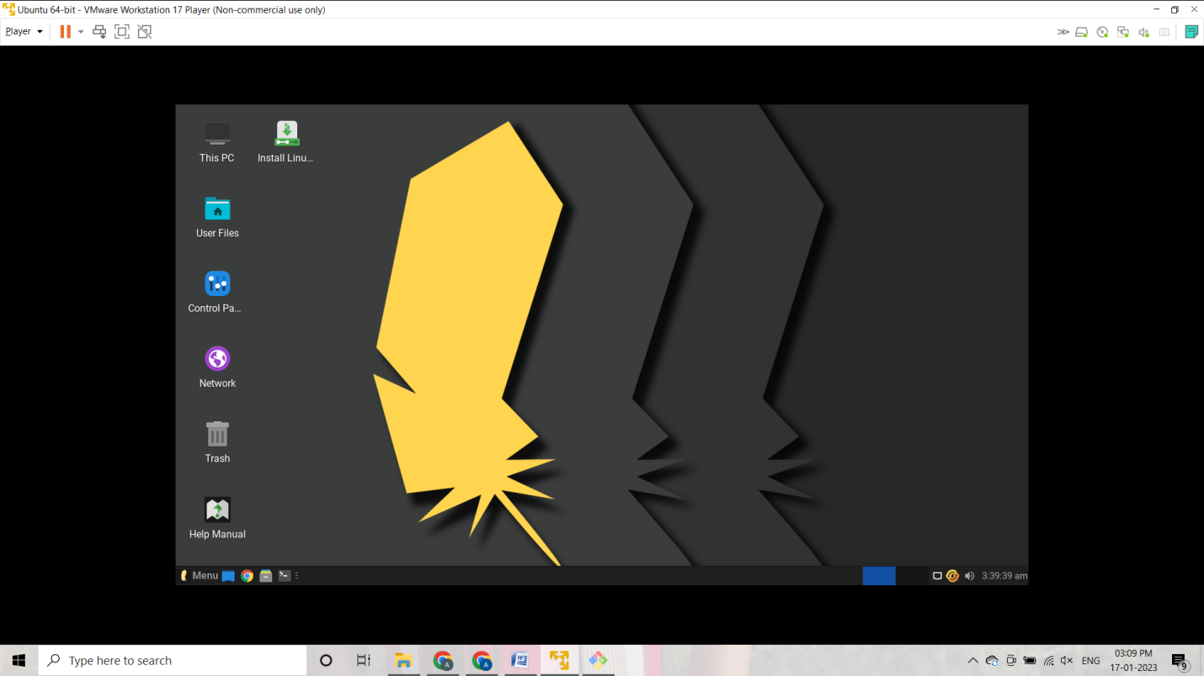

1. Create a VM in AWS/Azure

**AWS**:

